Biology 1 Name:
Photosynthesis & Cellular Respiration Date:
Making a Connection Hour:
Question | Photosynthesis | Cellular Respiration
The equation is shown on what page in the book?
What gas is made?
What other material is made?
What gas in needed?
What other material is needed?
Is light required?
Does it occur in autotrophs, heterotrophs or both?
Is it going on inside of you?
Does it occur in an oak tree?
What cell part does it occur in (mainly)?
Is it a “building up” or “breaking down” process?
Is it a single step or a multi-step chemical reaction?
Is there a net gain of ATP molecules?
Does it raise or lower the amount of oxygen in the atmosphere?
Does it raise or lower the amount of carbon dioxide in the atmosphere?
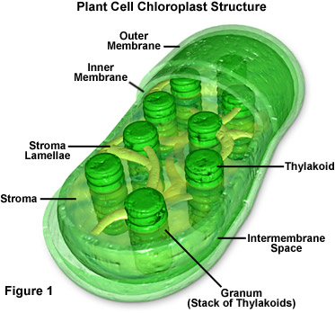
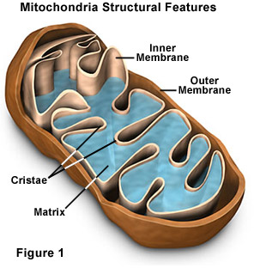
Why are photosynthesis and respiration considered complimentary processes? (Use at least 3 facts from the chart in your answer)

