Biology 1 Name:

Evolution Date:
Introduction Assignment Hour:

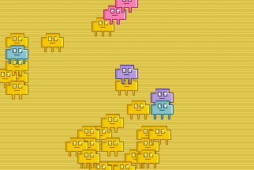
Record all of your answers on the back of this page.

- Visit http://www.pbs.org/wgbh/nova/evolution/evolution-action.html
- Click “Launch Interactive” and read the instructions.
- Allow the population to grow for a while spreading out the organisms as instructed. Answer the following questions.
  - What color is the environment?
  - What color are most of the organisms?
  - Are there any other colors that appear? Describe how/and when they appear (random/or in a specific pattern)
- Pick a new color and change the environment to that color.
- Allow the organisms to grow for a while and spread them out periodically.
- What happened to the composition of the population when the environment color was changed? Be descriptive.

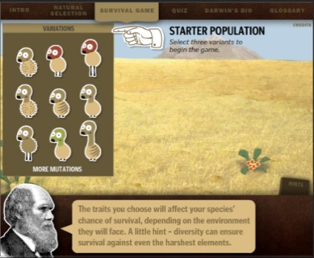

- Visit https://coolsciencelab.com/who_wants_to_live_a_million_years.htm
- Answer the following questions by clicking on “Darwin’s Bio”
  - When was Charles Darwin alive?
  - When and where did Darwin travel on the HMS Beagle?
  - What did Darwin observe on the voyage?
  - What is the name of the book containing Darwin’s published theory?
- Click “Survival Game” and play it. It may take you a couple of trials before you get the hang of it. You probably won’t be able to “win” the first few times. Once you’ve won, complete the following:
  - What did the original three organisms look like? Draw them.
  - What did the organisms look like after 1 million years?
  - What environmental changes occurred to influence your population?
  - How did those environmental changes impact your populations? (What changes did they encourage?)

8c.
8d.
3a. | 3b.
3c.
9a. | 9a. | 9a.
9b. | 9.c
9d.
6.

8a. | 8b.

