Name______________________________ Hour __________ Date______________

***Accuracy of Estimates Lab***

**How accurate will I be in estimating different kinds of measurements?**

In scientific measurement, the degree of precision required varies. Usually very precise

measurements are necessary but it is still helpful to be able to make estimates. The degree of accuracy in estimating varies considerably with the individual and the extent of his/her experience. The first time a person attempts to make an estimate, his/her accuracy is probably much less than it would be the tenth time.

How accurate will you be in estimating different kinds of measurements? In this investigation you will find out by making several estimates, comparing them to the precise measurements and then calculating your percent accuracy. In the process you will also gain experience in using some of the equipment and measuring tools that we will be using throughout the year in this class. ***Percent accuracy is calculated in two steps using the following formulas:***

**Step 1:** units off x 100 = % error

correct units

**Step 2:** 100% ­­— % error = % accuracy

**MATERIALS**

Metric ruler, graduated cylinder, balance, nickel, sand, weighing cup, clock with second hand.

**PROCEDURE**

**A. ESTIMATING LENGTH**

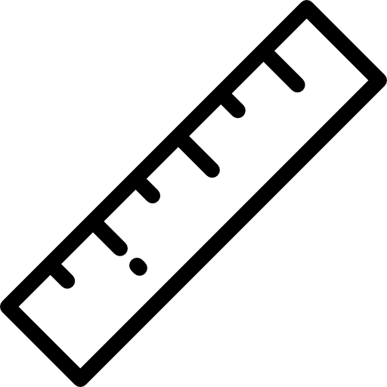1. On your lab paper (below your data table) draw a line freehand that you think is 10 cm long. Do not look at a ruler as you do this (however it may help to know that 30.5 cm is approximately 12 inches). Label this line “ESTIMATE”. Now, using the ruler, draw a line right below your estimate that you measure to be exactly 10 cm long. Label this line “CORRECT”. Enter the value 10 cm in the “correct units” column on your data table.

2. Measure your “estimated” line and enter this value under “estimate” on your data table. Determine how many cm off your line was from the “correct” and enter this in the “units off” column.

3. Using the formulas given, calculate your % accuracy and record it on your data table. Be sure to “show your work” in the “Calculations” column.

**B. ESTIMATING VOLUME**

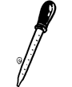4. Find the 5 ml level on the graduated cylinder. Estimate the number of drops of water that it would take to fill the graduated cylinder to this level. Record this estimate on your data table.

5. Now use your dropper to determine how many drops it actually takes to fill it to the 5 ml mark. This is your “correct units”. Record this, then determine units off and percent accuracy as you did in Part A.

**C. ESTIMATING WEIGHT**

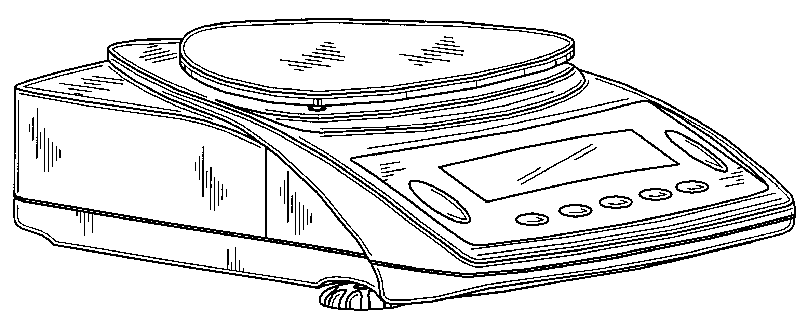*In this part of the investigation you will try to guess the amount of sand it would take to equal the weight of a nickel. In doing this section be sure to carefully follow all of the guidelines in Reference Sheet 6.*

1. Place the nickel in a cup and hold it to get an idea of its weight. Now carefully spoon sand into a second g cup until you think the amount of sand weighs the same as the nickel. *BE CAREFUL NOT TO GET ANY SAND ON THE BALANCE!*

2. Find the weight of the sand. (*Careful! What do you need to do to take into account the weight of the cup??*) The weight of the sand is your estimate. Record on your data table.

3. Now weigh the nickel. This is the “Correct” weight. Record.

4 Using the formulas in the introduction, calculate and record your percent accuracy.

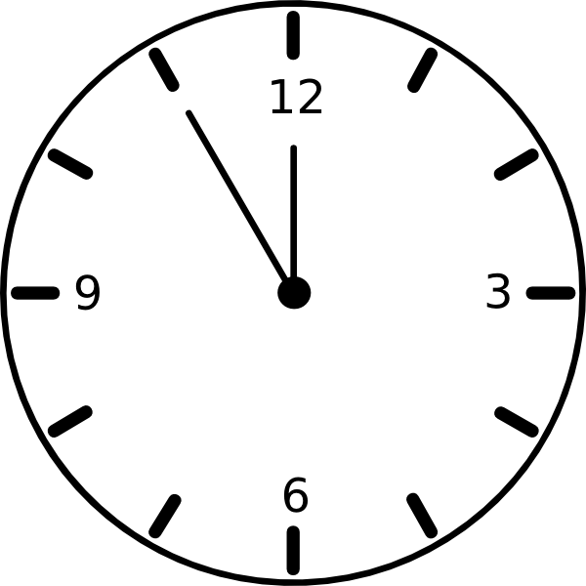

**D. ESTIMATING TIME**

*In this section you will try to estimate how long 30 seconds is without looking at a clock. You and your lab partner will take turns being estimator and timer.*

1. Have your lab partner watch a clock with a second hand. Have your partner tell you when to start, then, when you think 30 seconds have passed, you say “Stop”.

2. The number of seconds that passed before you said “Stop” is your estimate. 30 seconds is the “correct” time you were trying to determine. Record these numbers and determine your percent accuracy as in parts A, B and D.

3. Repeat, switching roles with your partner.

**E. AVERAGE PERCENT ACCURACY**

1. Calculate the average of the five % accuracies you obtained for steps A through D. Record this figure on your data table.

2. Record your average in the space provided.

**INDIVIDUAL DATA**

|  |  |  |  |  |  |  |
| --- | --- | --- | --- | --- | --- | --- |
| Dimension | Estimate | Correct Units | Units Off | % Error | % Accuracy | Calculations |
|  |  |  |  |  |  |  |
|  |  |  |  |  |  |  |
|  |  |  |  |  |  |  |
|  |  |  |  |  |  |  |

Average % Accuracy:

Enter the numbers of students in your class who had percent accuracies in each range.

**CLASS DATA**

|  |  |
| --- | --- |
| **Average % Accuracy** | **Number of Students** |
| 100-96 |  |
| 95-91 |  |
| 90-86 |  |
| 85-81 |  |
| 80-76 |  |
| 75-71 |  |
| 70-66 |  |
| 65-61 |  |
| 60-56 |  |
| 55-51 |  |
| 50-46 |  |
| 45-41 |  |
| 40-36 |  |
| 35-31 |  |
| 30-26 |  |
| 25-21 |  |
| 20-16 |  |
| 15-11 |  |
| 10-6 |  |
| 5-0 |  |

Plot the information from your table below. (Remember to follow all guidelines discussed in our notes)

* 1. Draw a “best fit” line (in this case it will be a curve).
  2. Place an “X” on the “best fit” curve to indicate your own average % accuracy.

____________________________________



Number of Students

|  |  |  |  |  |  |  |  |  |  |  |  |  |  |  |  |  |  |  |  |
| --- | --- | --- | --- | --- | --- | --- | --- | --- | --- | --- | --- | --- | --- | --- | --- | --- | --- | --- | --- |
| 0-  5 | 6-  10 | 11-15 | 16-20 | 21-25 | 26- 30 | 31-35 | 36-40 | 41-45 | 46-50 | 51-55 | 56-60 | 61-65 | 66-70 | 71-75 | 76-80 | 81-85 | 86-90 | 91-95 | 96-100 |

Average Accuracy %

3. In which area of estimating were you the most accurate? Do you think your accuracy was more a matter of luck or experience? Explain.

4. Write a paragraph describing what you have learned by doing this investigation and how it will help you in the future in science.